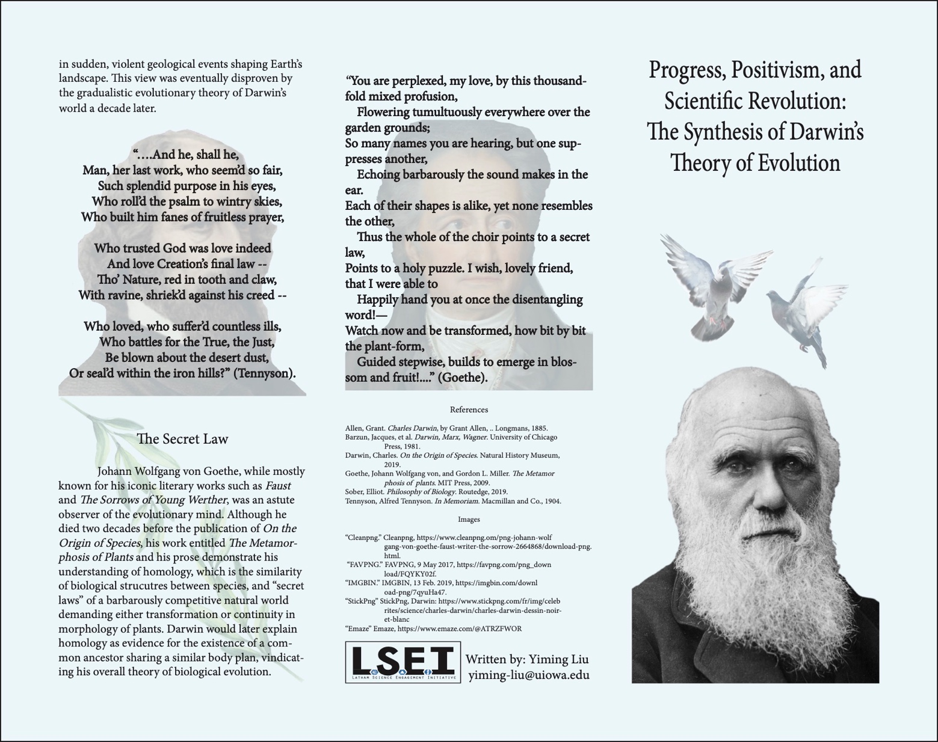

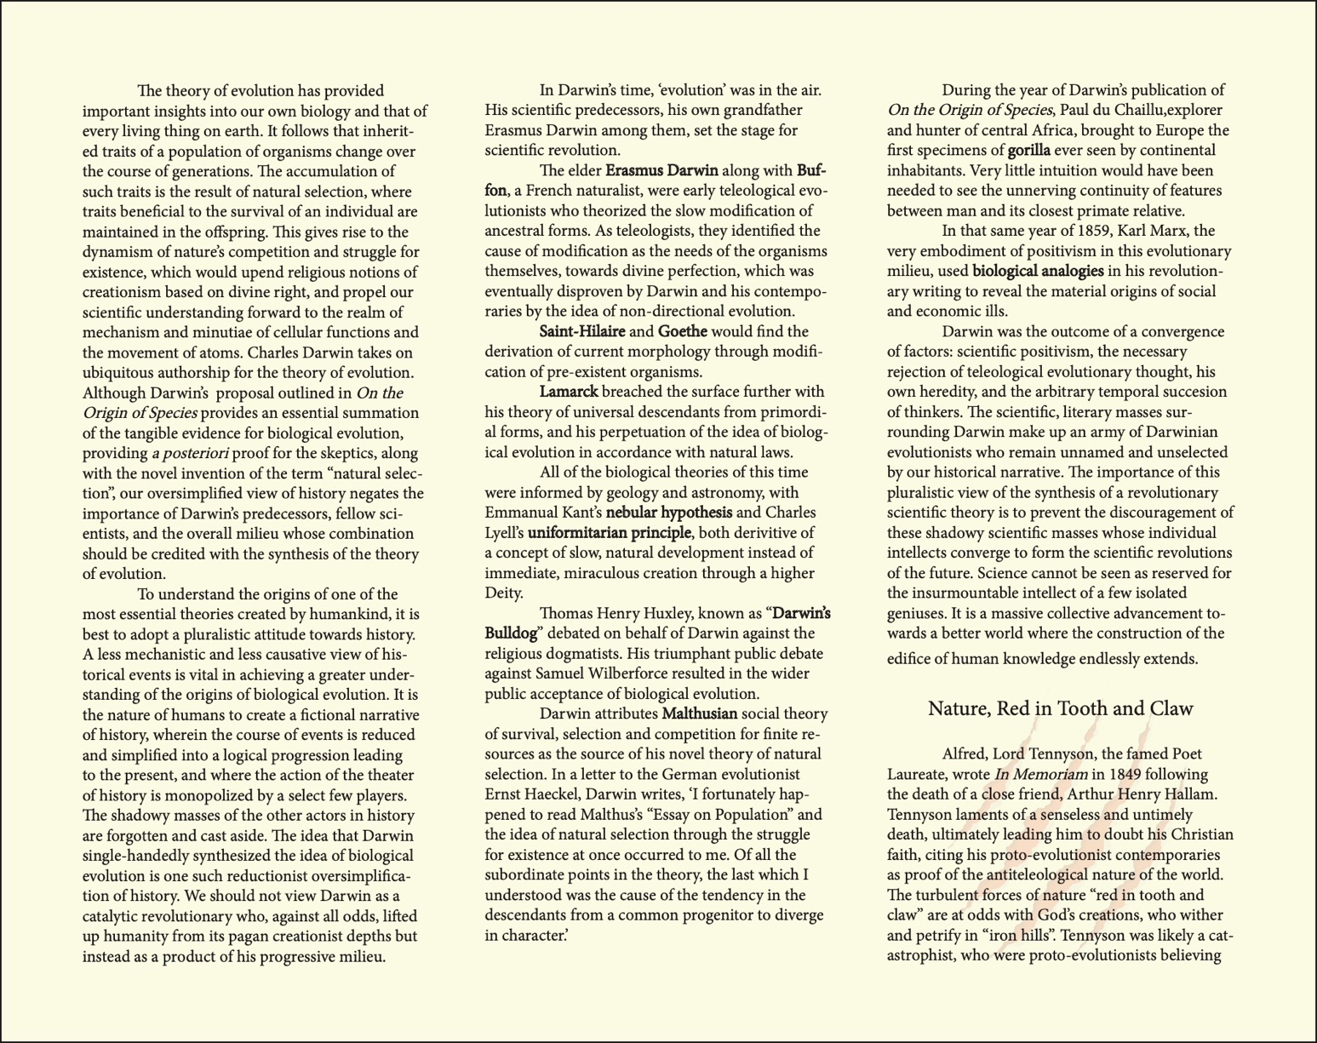
called the “Father of biogeography”, founded his own theory of natural selection independently of Darwin. Wallace’s work provided crucial evidence for Darwin’s theory.
The lesser-known Alfred Russel Wallace,

This document was made to be read as a tri-fold brochure. Print out the document double-sided, fold right side inward, then left side inward. Yellow side is inside, blue side is outside.

