The Everyday Wonders of Science
Coming from a small town, I didn’t have a lot of access to science. Outside of the classroom there were very few opportunities to learn more about how science works and how it is used in our society today. After coming to the University of Iowa, I immediately fell in love with the idea of sharing science with others. When thinking about what my Latham Science Engagement Initiative fellow project would look like, I knew that I wanted to do something that could encourage kids who grew up in a small town like me to fall in love with science.
My ultimate goal was to make science more accessible to rural communities as they are my target audience. By highlighting the ways in which science operates around us, my hope is that people will gain an appreciation for science and continue to explore their own scientific curiosity. Over the course of the first semester, I had a lot of wavering thoughts about how I could implement this idea. Connecting with rural communities is particularly difficult because there are fewer communal areas and event spaces that would incorporate entire communities. I decided on creating a podcast as I felt that it was the most effective way to reach my target audience. Nick Benson in the Office of Community Engagement helped me to address these challenges by suggesting that I partner with public libraries. These spaces would allow me to share my podcast with a lot of people through the library as well as through their Facebook pages, which is one of their major forms of communication within the community. Once this was accomplished, I began conducting interviews for the content portion of my podcast. Finally, I edited the podcasts. Editing was the most enjoyable part of the process as I finally got to see my idea come to fruition. Image 2 shows me editing the podcast in Audacity.
My project lives primarily in the digital universe as it is available on Spotify and on Stem-O-Sphere. As a way to direct people to the podcast, I have created a flyer, see image 1, that I distributed to the various public libraries to display. The flyer contains a QR code for easy access to Stem-O-Sphere. In addition, there is a google form located on Stem-O-Sphere for people to leave reviews and provide any feedback that they may have about the podcast. At the end of the day, I want to know if I am reaching my target audience, so I am hoping that people will take the time to share their thoughts about the podcast.
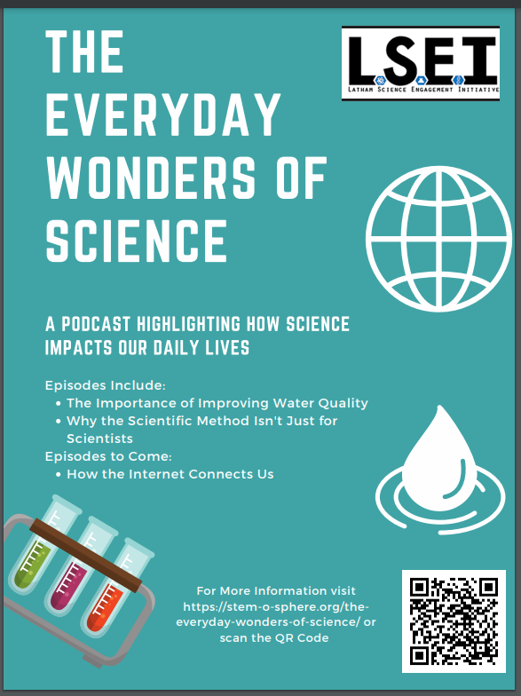
Image 1. A flyer I created to give to public libraries in order to increase engagement with the podcast as well as a way to direct people to other Latham projects on Stem-O-Sphere.
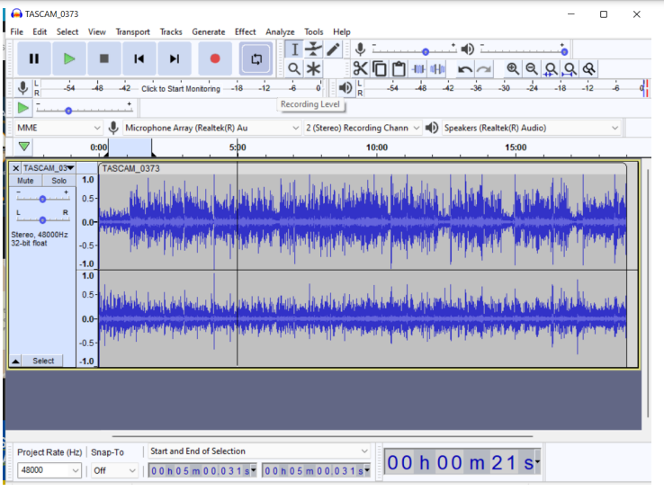
Image 2. The early stages of me editing the podcast in Audacity. Audacity is a free digital audio editing
software.

