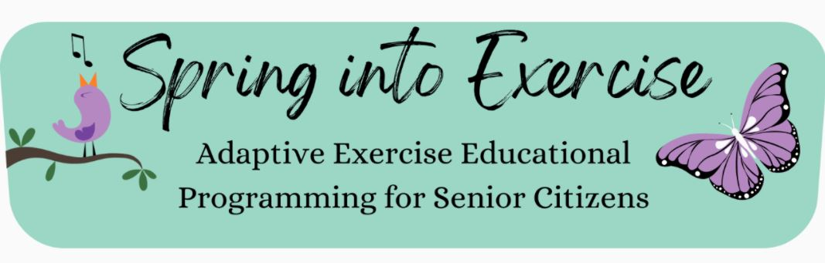

Adaptive Exercise Educational Programming
for Senior Citizens in Johnson County

Developed by Grant Welk
2022 Latham Science Engagement Initiative Fellow
For two years in high school, I routinely woke up at 5 AM before class to lifeguard for a water aerobics class with older adults. What I most appreciated about this position was getting the opportunity to get to know many attendees personally. Over time, I watched some seniors lose their mobility and stop coming to class, eventually losing touch with a close social group they previously had. I similarly saw other seemingly healthy seniors become more fearful of losing their own functional independence. They were worried about their changing health and wanted to work as hard as they could to remain active and independent.
Growing up, exercise was continuously stressed in my house, as my mom is a Physical Therapist and my dad is a Professor in Kinesiology. From them, I learned to recognize the numerous benefits that physical activity has for our physical and cognitive health as well as our emotional well-being.¹ Hearing about exercise so frequently, I developed an interest in studying how exercise changes our body’s physiology.
From the older adults that I worked with, however, I learned the reverse: how our body’s physiology and age affect exercise. With more chronic health conditions, health recommendations become increasingly complicated. Therefore, those with pre-existing health conditions often require significant adaptations to exercises when restarting a fitness routine. These adaptations require a greater understanding of the physiological mechanics of exercise that those without a routine do not always have. While this accessibility barrier exists across demographics, it poses a particular risk for seniors because maintaining physical activity with age significantly reduces the risk of disease and premature death.¹ This realization stuck with me, as I saw how difficult, yet important, it can be to maintain your mobility with age. Fitness and mobility allow us to live longer and healthier lives and connect with support groups outside of the house that are important for our mental and social health.
With the COVID-19 pandemic, many health programs for seniors were discontinued, leaving seniors without opportunities to access exercise resources and retain in-person social connections. In Johnson County specifically, many exercise programs had still not returned by the end of 2021, despite the great need for more programming with its growing senior population.
After seeing this need, I hoped to organize science-based outreach to provide local seniors with more resources to help them adapt to stay active. I later adapted and focused my product vision to account for my close partnership with the Iowa City Senior Center and their seniors’ specific difficulties with using and understanding the available exercise equipment. As a result, my individual project developed into a three-week “Spring into Exercise” program consisting of three different events:

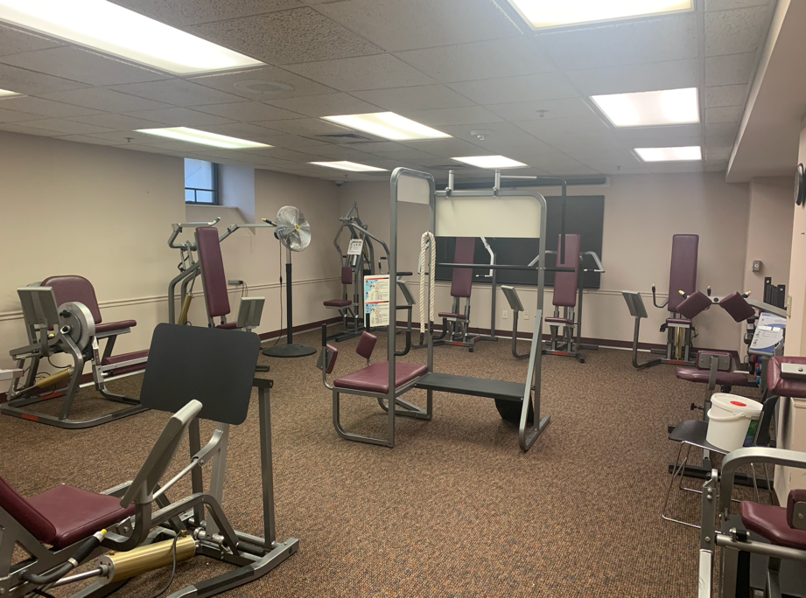
Session 1
The first session included personalized explanations of adaptations to exercise equipment at the center. While there was only one attendee, she appreciated the extra attention since she was inexperienced with resistance exercises and had both knee arthritis and post-surgery shoulder pain. However, I also recognized that other routes of information distribution were important for broader project success. As a result, I developed informational posters that were hung in the exercise room and shared online.
Image 1. Exercise Room at the Iowa City Senior Center

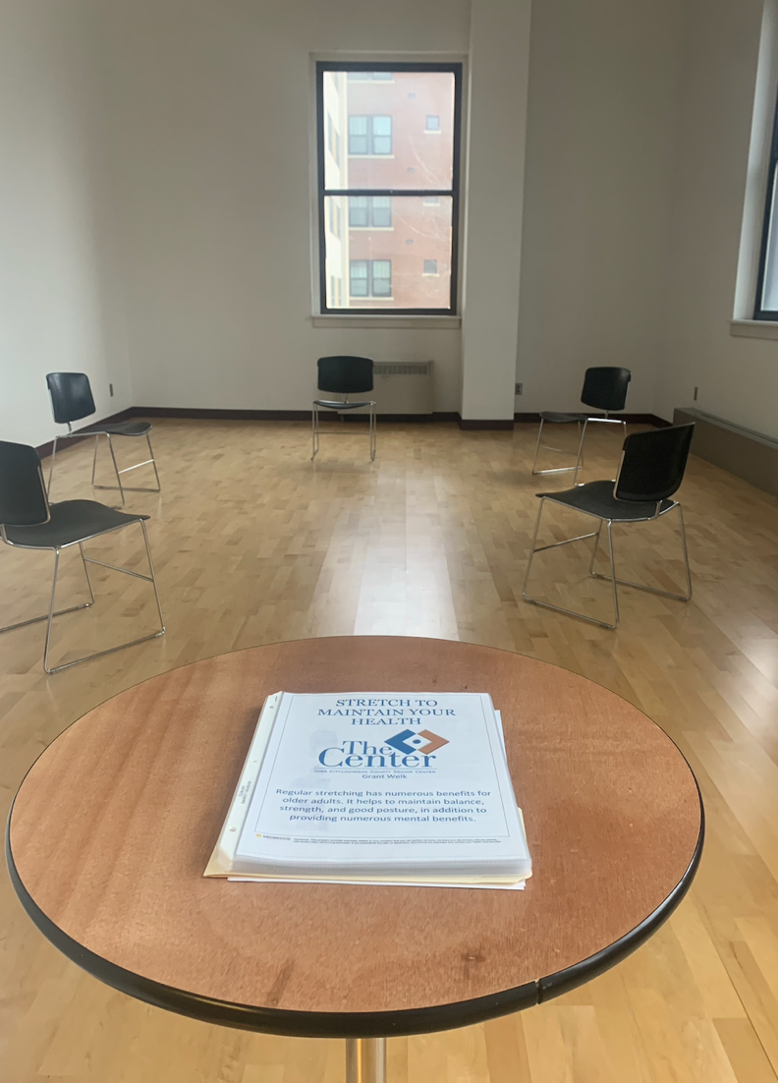
Session 2
The second session incorporated demonstrations of stretches and adaptations reviewed by a Physical Therapist. This was designed to stress the importance of daily flexibility for the maintenance of functional independence. As such, attendees were given handouts with adaptable stretches to take home for use outside of the senior center. To increase attendance, I reached out to the local Oaknoll Assisted Living Community organization for event promotion. While attendance was capped to accommodate social distancing, the attendance of only three seniors was still lower than initially planned. Therefore, additional handouts were left with the Senior Center, and the information was shared online for continued distribution
Image 2. Setup for Chair Stretching Session

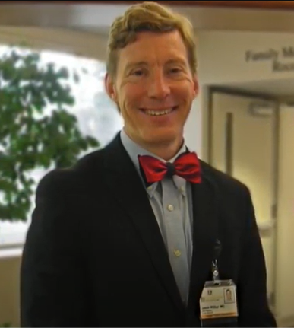
Session 3
The third and final session consisted of a joint-led lecture with a Geriatrician about how physical activity mitigates physiological changes with aging. With 14 attendees, this event had an improved turnout. This may be due to being held virtually and following more intensive event promotion. The lecture was followed by a discussion for individuals to ask questions about exercise to the physician, since local access in Eastern Iowa to primary care appointments varies. The lecture was edited and consolidated before being shared to the Senior Center, published on YouTube, and distributed to the Heritage Area Agency on Aging.
Image 3. Jason Wilbur, MD, FAAFP

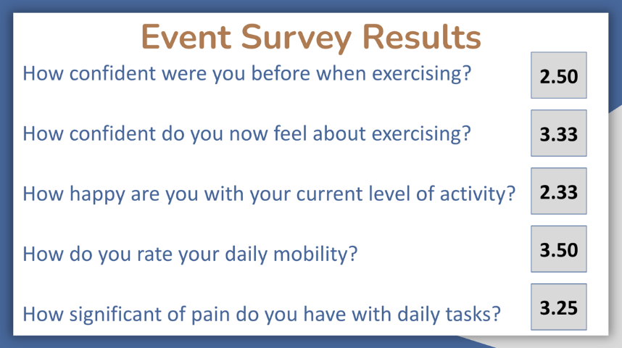
While attendance of the Spring into Exercise program was limited, the personal impact was still significant. Collectively, the seniors that participated felt more confident about exercising after program completion, with an average rating of 2.5 beforehand and 3.33 afterward. This rating was based on a scale of 5, with 1 representing being “Not confident at all” and 5 representing being “Very confident.”
Image 4: “Spring into Exercise” Survey Results
These positive results suggested that the seniors in Iowa City still do not feel very confident about exercise, however, additional emphasis on exercise programming could be beneficial and appreciated. Exercise is Medicine On Campus at Iowa, a student organization at the University of Iowa will consider future partnerships with the Senior Center to sustainably expand on the program. Completing this project taught me that scientific outreach is hard work that requires both consistent planning and flexibility; nevertheless, outreach is important and has the opportunity for significant, sustained personal impact by bringing complicated sciences closer to the public eye.
References

Feng, N., Ryan, E., Kidane, M., Tusch, E., Brittany M., Roger Carlsson, M., Mohammed, A., Håkansson, K., Daffner, K. (2019). Feasibility of an at-home, web-based, interactive exercise program for older adults, https://doi.org/10.1016/j.trci.2019.10.005.
Forbes, D., Thiessen, E. J., Blake, C. M., Forbes, S. C., & Forbes, S. (2013). Exercise programs for people with dementia. The Cochrane database of systematic reviews, (12), CD006489. https://doi.org/10.1002/14651858.CD006489.pub3.
Johnson County Public Health. (2016). 2016/2020 Johnson County Health Improvement Plan, 1-39. https://www.johnsoncountyiowa.gov/sites/default/files/2020-04/2016%20JC%20HIP.pdf.
King, A. C. (2001). Interventions to Promote Physical Activity by Older Adults, The Journals of Gerontology: Series A, 56(2), 36–46, https://doi.org/10.1093/gerona/56.suppl_2.36.
Warburton, D. E., Nicol, C. W., & Bredin, S. S. (2006). Health benefits of physical activity: the evidence. CMAJ : Canadian Medical Association journal = journal de l'Association médicale canadienne, 174(6), 801–809. https://doi.org/10.1503/cmaj.051351.
Whelk, Grant. “The Health Benefits of Staying Active with Age” YouTube, uploaded by Grant Whelk, Apr 30, 2022, www.youtube.com/watch?v=Hc_JR5HfFEQ.

